**01. Introduction to Microservices Distributed Tracing using AWS X-Ray**

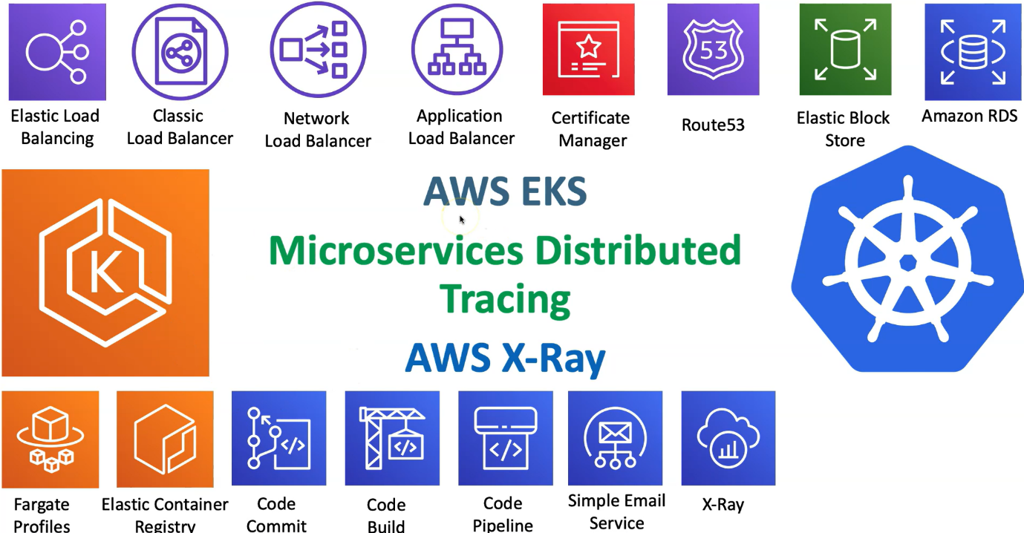

--- In this section, we are going to look into AWS X-ray as one of the tools for Microservice distributor tracing.

--- we are going to deploy our applications on EKS And then those microservice applications, we are going to enable distributor tracing using aws X-ray.

--- we are going to add one more aws service to our entire deployment. moving on, we will see on a very high level. What is aws x ray and how we are going to deploy it. what is its network architecture? during the process, we are also going to look into daemonsets in kubernetes.

--- we are going to deploy x-ray related application on kubernetes using daemonsets. let's see all those things.

**AWS x-ray introduction**

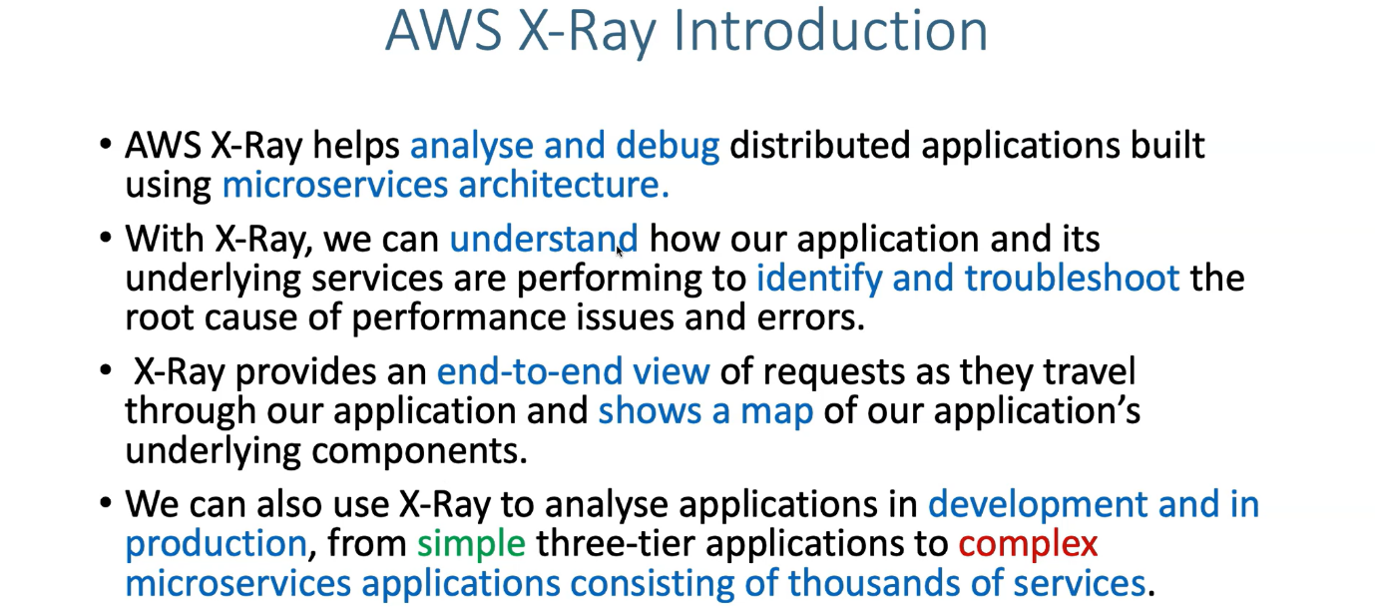

**AWS X-ray Benefits**



**AWS x-ray – how it works**

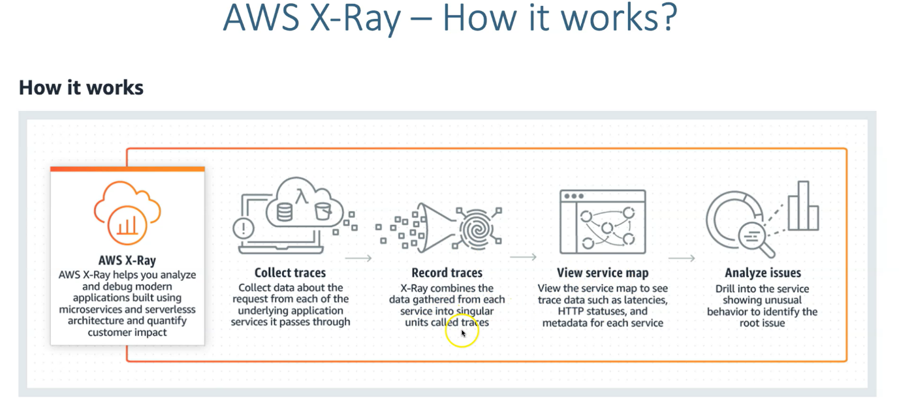

**Kubernetes daemonsets – introduction**

--- we are going to deploy X-ray related agent on kubernetes using daemonsets. due to that, we need to understand what are daemonsets.